

**Comsats University Islamabad, Lahore Campus**

**Course Title: OOP**

**Name: Fatima Chaudhry (SP24-BSE-024)**

**Section: A**

**Submitted to: Sir Shahid**

**Lab Task # 3**

Data Form Layout:

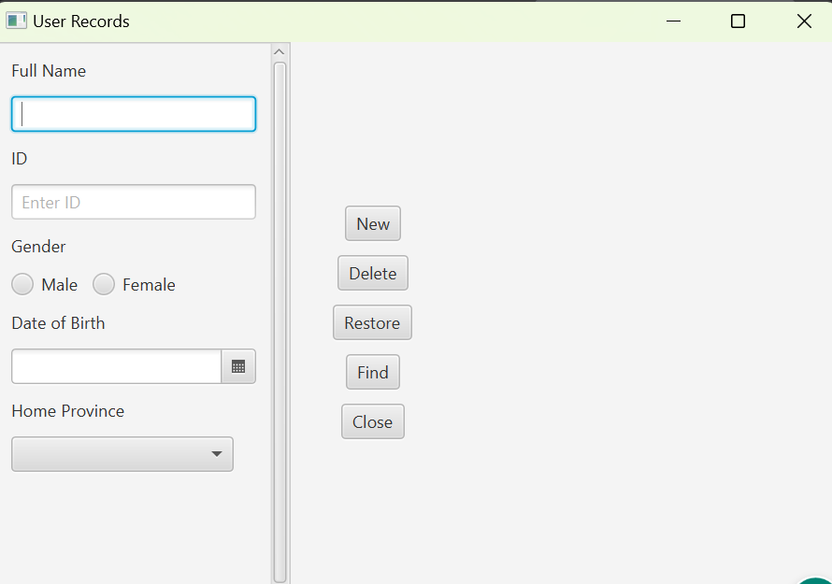

Data Entered:

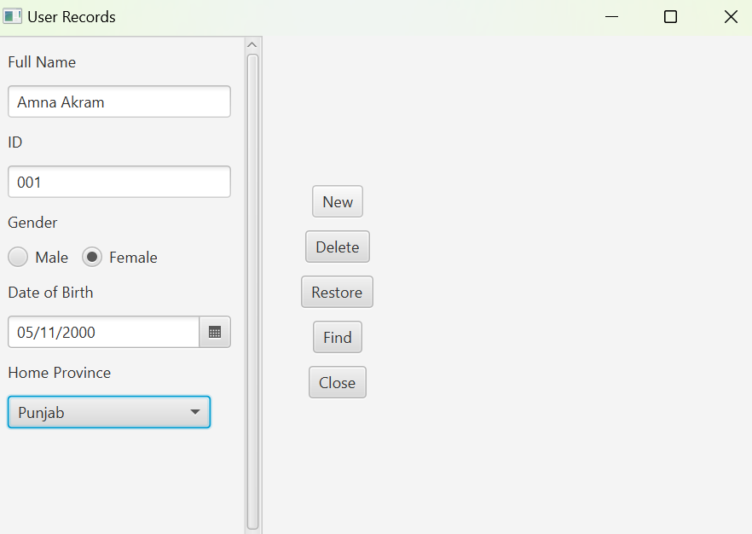

Shows data saved in file:

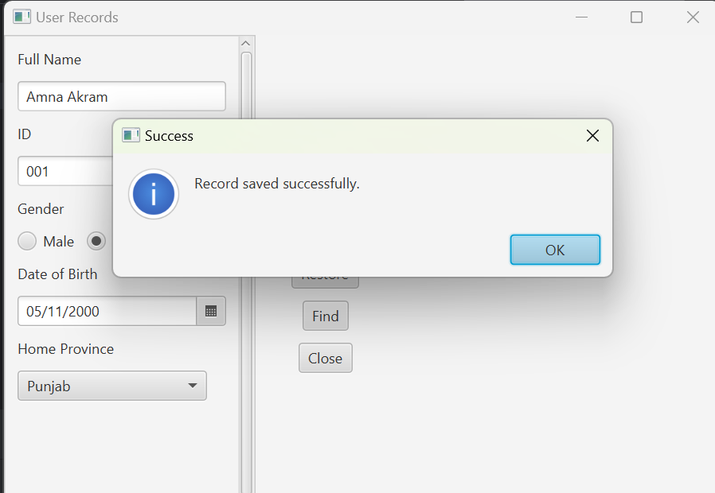

Txt File showing data stored: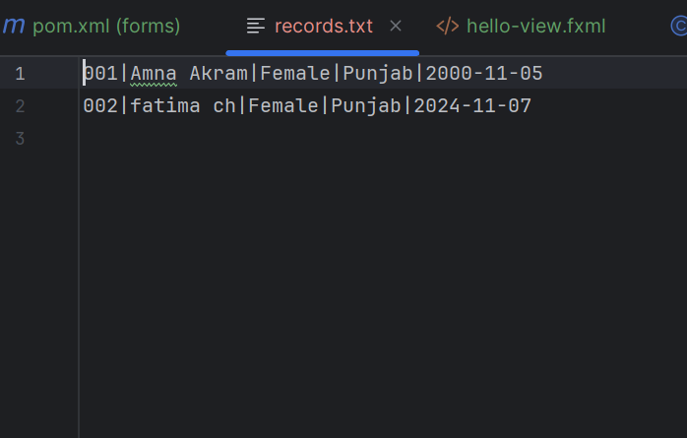

ID entered to check if same ID is present:

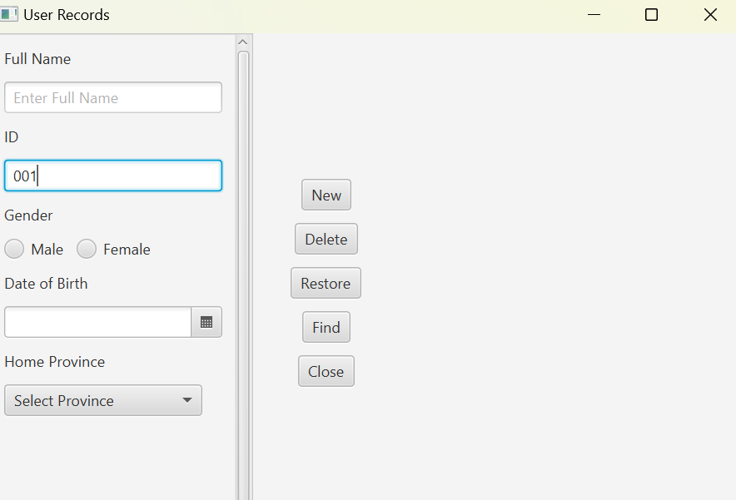

When Clicked on find button the info appeares

